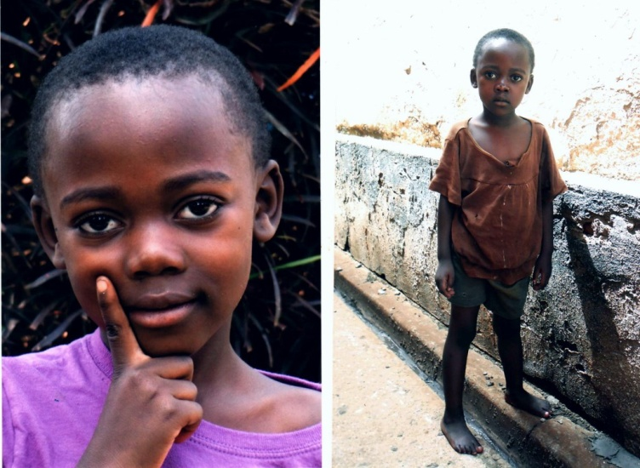

MARIA PRAISE NAMAKULA

She was brought to our attention after her parents had been involved in an accident.The father passed on and mother sutained brain damages and was disabled.She stayed with an auntie who also died of cancer.She was brought to us and we took her in.she is now in primary two.

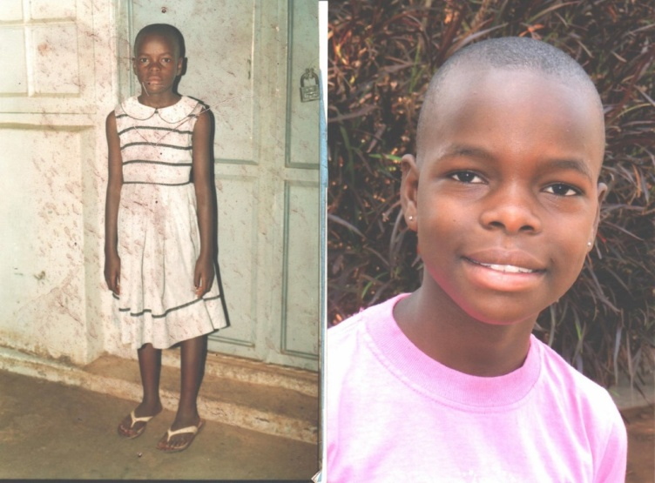

PRAISE KITAKA

Her father lost everything plus relatives during the war in the north- Lira.He got frustrated and got mental illness.We were building stoves in Abako when this case was brought to our attention.She is currently in primary six.

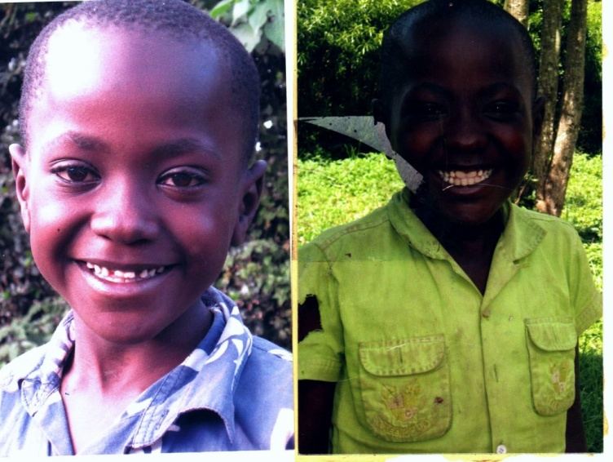

**KEVIN MUGALYA**

The Father died of Hiv/Aids. After burial the mother a Sudanese abandoned him at a neighbors’ and went back to sudan.Was brought to our attention by the probation and welfare deparment.We took him on and he is now in primary six.

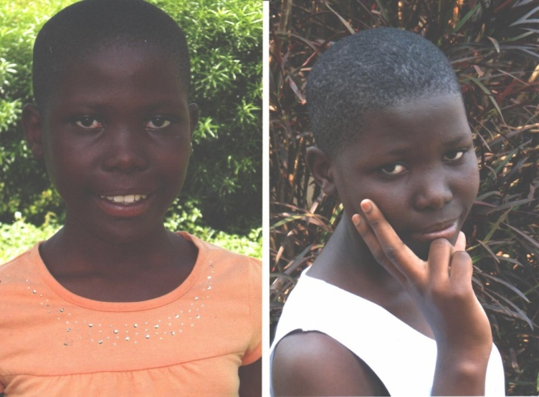

**ESTHER KISAKYE**

Her parents hailed of kisima island but one time to the way back home in boat it broke down and they drowned. She went to live with and auntie who was later imprisoned. We had gone for an outreach on the island when the local council leader brought her to our attention. She has been with us since and is now in senior four.

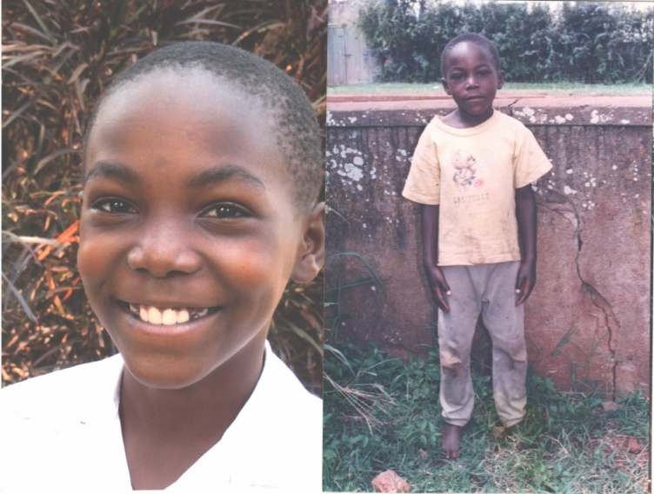

**EDDY MASIGA**

His father was a soldier who was died during the war in northern Uganda. The mother abandoned him at church. He was brought to our attention by the church members. We took him on and is now in primary six.

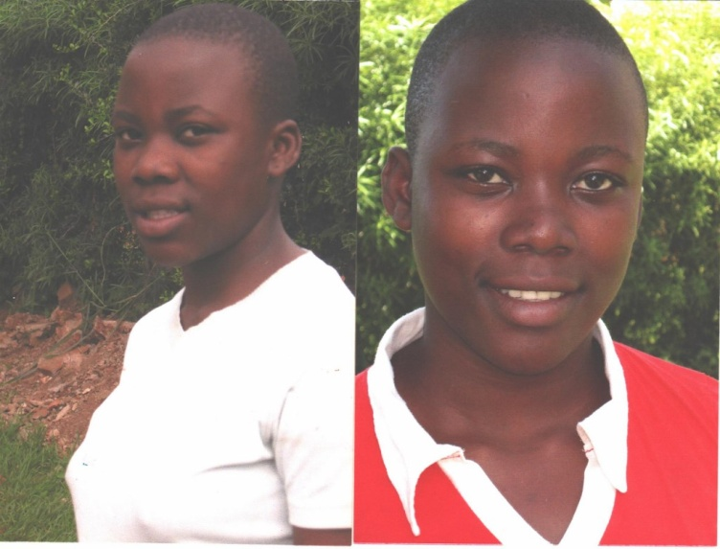

**RUTH BAKITA**

Her father died .The mother left her with a drunken grandmother she had gone to Congo to seek for jobs but has never returned. She was brought to us by another community service organization with which we net work. She is now in senior three.

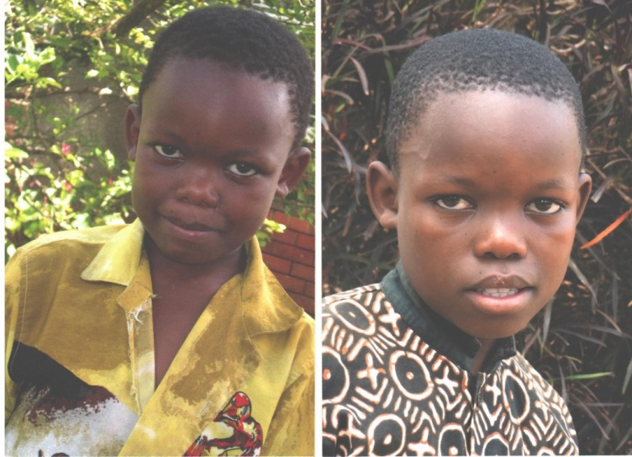

**SADAT SOLOMON WABOYA**

Lost both parents to HIV/Aids. Left with a poor very old grandmother. Brought to us by the local leaders. He is now in primary six.

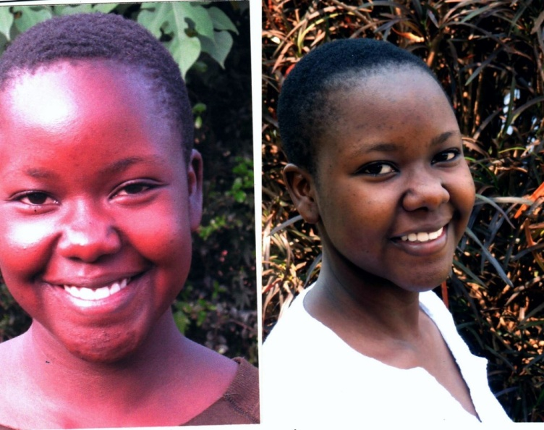

**ESTHER CREENZA NALUUMA**

Lost the father and they lived with their mother .She abandoned them to unknown destination. Brought to us by concerned members of the community. She is in senior six and aspiring to become an architect